**Topics: Descriptive Statistics and Probability**

1. Look at the data given below. Plot the data, find the outliers and find out $μ, σ, σ^{2}$

|  |  |
| --- | --- |
| **Name of company** | **Measure X** |
| Allied Signal | 24.23% |
| Bankers Trust | 25.53% |
| General Mills | 25.41% |
| ITT Industries | 24.14% |
| J.P.Morgan & Co. | 29.62% |
| Lehman Brothers | 28.25% |
| Marriott | 25.81% |
| MCI | 24.39% |
| Merrill Lynch | 40.26% |
| Microsoft | 32.95% |
| Morgan Stanley | 91.36% |
| Sun Microsystems | 25.99% |
| Travelers | 39.42% |
| US Airways | 26.71% |
| Warner-Lambert | 35.00% |

Ans: mean ($μ)$ = 33.2713

Variance ($σ)$ = 287.1466

Standard Deviation $(σ^{2})$ = 16.9454

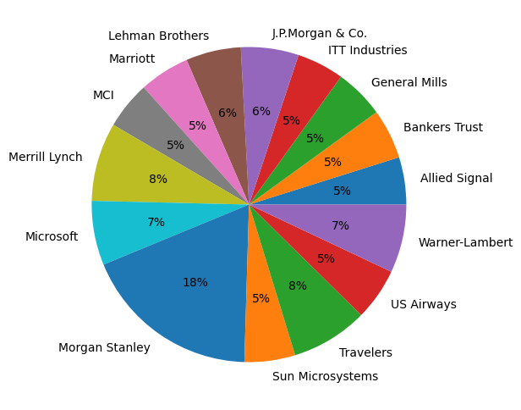

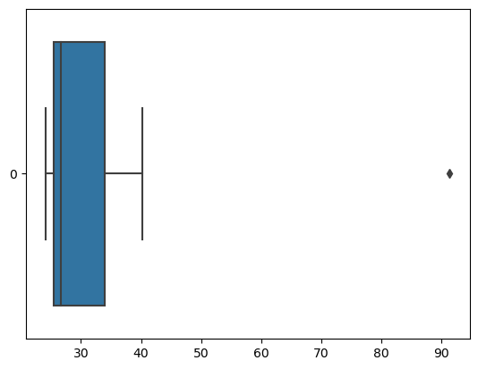



Answer the following three questions based on the box-plot above.

1. What is inter-quartile range of this dataset? (please approximate the numbers) In one line, explain what this value implies.
2. What can we say about the skewness of this dataset?
3. If it was found that the data point with the value 25 is actually 2.5, how would the new box-plot be affected?0

Answer: i) Here 25 is the outlier

median is 7

1st quartile (Q1) = 5

2nd quartile (Q2) = 12

IQR = 12 – 5 = 7

IQR tells us the range of the middle half of the data.

ii) data is right skewed.

iii) In that case there would have been no outliers, and it might have affected in the

values of mean and median slightly. The boxplot might have moved towards right

slightly.



Answer the following three questions based on the histogram above.

1. Where would the mode of this dataset lie?

Answer: Between most frequent data i.e. between 5 to 8.

1. Comment on the skewness of the dataset.

Answer: Positively Skewed.

1. Suppose that the above histogram and the box-plot in question 2 are plotted for the same dataset. Explain how these graphs complement each other in providing information about any dataset.

Answer: If we compared both the plots then it is very clear that is positively skewed and it will

Help us to calculate mean, mode value.

1. AT&T was running commercials in 1990 aimed at luring back customers who had switched to one of the other long-distance phone service providers. One such commercial shows a businessman trying to reach Phoenix and mistakenly getting Fiji, where a half-naked native on a beach responds incomprehensibly in Polynesian. When asked about this advertisement, AT&T admitted that the portrayed incident did not actually take place but added that this was an enactment of something that “could happen.” Suppose that one in 200 long-distance telephone calls is misdirected. What is the probability that at least one in five attempted telephone calls reaches the wrong number? (Assume independence of attempts.)

Answer: Probability of call getting misdirected = $\frac{1}{200}$

Hence probability of calls not getting misdirected = $1-\frac{1}{200}$ = $\frac{199}{200}$

Number of phone calls attempted = 5

So, probability that at least one in 5 attempted calls reaches the wrong number

= $1-(\frac{199}{200})$ ^5

= 0.025

1. Returns on a certain business venture, to the nearest $1,000, are known to follow the following probability distribution

|  |  |
| --- | --- |
| x | P(x) |
| -2,000 | 0.1 |
| -1,000 | 0.1 |
| 0 | 0.2 |
| 1000 | 0.2 |
| 2000 | 0.3 |
| 3000 | 0.1 |

1. What is the most likely monetary outcome of the business venture?

Answer: $2000

1. Is the venture likely to be successful? Explain

Answer: yes, because 60% chance to give result and 20% chance of failure and 20% chance to

no loss and no profit.

1. What is the long-term average earning of business ventures of this kind? Explain

Answer: Average earning of business venture =

(-2000*0.1) + (-1000*0.1) + (0*0.2) + (1000*0.2) + (2000*0.3) + (3000*0.1) = 800

1. What is the good measure of the risk involved in a venture of this kind? Compute this measure

Answer: We can calculate the risk by using the variance and standard deviation.

Variance = 3500000

Standard deviation = 1870.83

This venture at high risk because the standard deviation is $1870 with the average

Return of $800